1. 
2. **Agenda**:
   1. Steps in involved in the request and response.
3. **Steps**:
   1. 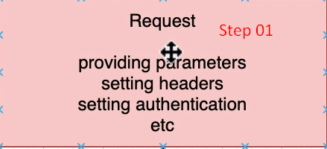  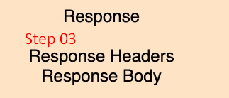
4. These are the steps involved in any test.
5. Let’s understand this in context of **Rest Assured.**
6. 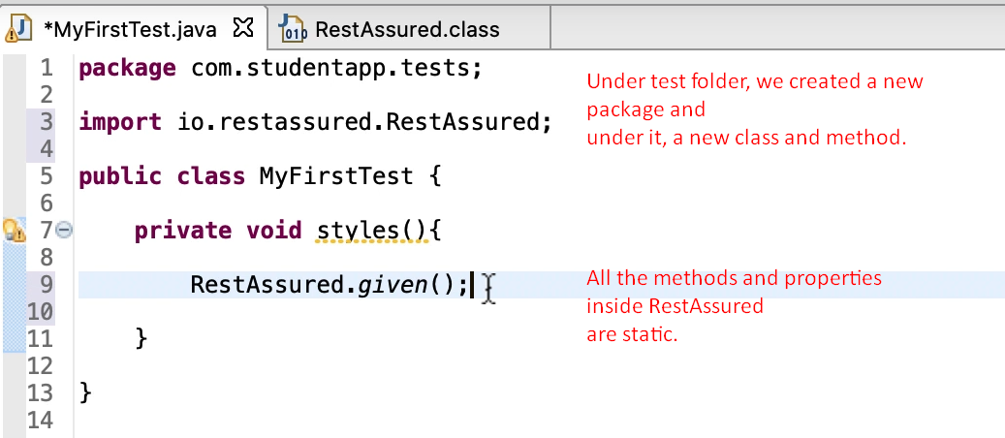
7. Rest Assured supports BDD Style (Given, When, Then).
8. Rest Assured supports some test writing styles
   1. 
   2. 
9. 